# Experiment No- 9

**Aim:** Write a program to create a database and Collection in MongoDB using NodeJS.

# Code:

**CREATE A DATABASE CODE:**

var MongoClient = require(‘mongodb’).MongoClient;

//Create a database named “mydb”:

var url = “mongodb://localhost:27017/”; MongoClient.connect(url, function(err, db) { if (err) throw err;

console.log(“Database created”); db.close();

});

# CREATE A COLLECTION CODE:

var MongoClient = require(‘mongodb’).MongoClient; var url = “mongodb://localhost:27017”; MongoClient.connect(url, function(err, db) {

if (err) throw err;

var dbo = db.db(“mydb”); dbo.createCollection(“customers”, function(err, res) {

if (err) throw err; console.log(“Collection created!”); db.close();

});

});

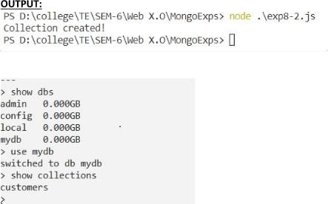

**Conclusion:** Thus, we have created a program to create a database and Collection in MongoDB using NodeJS.